22nd February 2020

Dear Competitor,

Please find attached/enclosed your invitation to take part in this year's Field Firing Match competition on Saturday 4th April 2020

As this is a one day event, would you please return your entry form completed with the rifle details and a cheque for the correct amount as soon as possible to avoid any disappointment, applications will be dealt with on a first come, first serve basis.

Food and Refreshments will be available so please let us know if you have any dietary requirements.

Best regards,

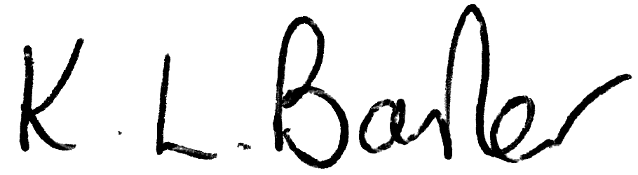

Kim Barker.

HERTS & ESSEX SHOOTING ASSOCIATION
In Association with
HISTORICAL BREECH-LOADING SMALL ARMS ASSOCIATION

Cordially invite you to take part in
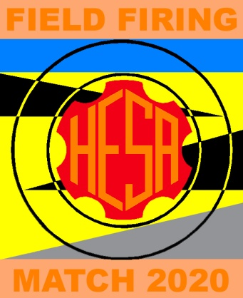

The Historic Field-Firing Match
Joint Miniature Rifle Meeting to be held on
Saturday 4th April 2020

At the
HESA Range Seabrook’s Farm
Church Lane Little Leighs
Chelmsford Essex CM3 1PG

Refreshments will be available with all profits to the
Royal British Legion Poppy Appeal

Closing Date for Entries: Monday 30th March 2020
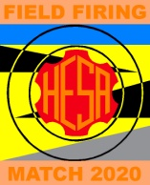
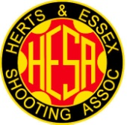
Herts and Essex Shooting Association
Miniature Rifle Open Meeting
“Field Firing Match”
Saturday 4th April 2020

Introduction: The event is in its thirteenth year at HESA;
Rifles must use ∙22RF or other miniature rifle cartridge as approved by the HESA or HBSA
(e.g. ∙297/∙230 Morris Tube, ∙310 Cadet or Air Rifle Pellet).
This match provides a loose representation of the Field Firing Training using targetry variously in use between the 1920’s and post Second World War.

Competitors: Members and Non-Members of the HESA, HBSA and LERA.

Match Conditions: As HBSA Rules 1995, (and this entry form).
However, orthoptic accessories, a padded glove and a sling (two point or as-issued) may be used.
A wrist rest may be used in sniping, or any classes.
Replica firearms in the "spirit of the original" (Rule G3.1) are permitted.
Multiple entries of each Match are permitted provided that a different firearm is used for each Entry. All arms shall be appropriately licensed and "in proof'. Targets will be as shown (see last page).

Handicapping: 3% Handicap will apply for magazine use, (except Matches IX & X).
5% Handicap may apply, if you are unable to shoot in all three positions.

Distance: 25 yards for all Classes.

Course of Fire: Unlimited non convertible sighter's (300 seconds)
Ten shots prone (Sand bag may be used) at 5 Tin Hat targets (2 shots per bull) (120 seconds).
Ten shots kneeling from behind “Cover” (Available support and sand bag may be used)
at 5 Landscape targets (2 shots per bull) (120 seconds).
Five shots standing shot over a “Fire Trench Parapet” (Available support and sand bag may be used) at 3 Figure 4A targets (5 shots on 3 bulls) (180 seconds).
Five shots standing shot over a “Fire Trench Parapet” (Available support and sand bag may be used) at 3 1931 snap targets (5 shots on 3 bulls) (1 per, 5 second exposure).

Match I: Vintage (pre-1888) Any Rifles (any contemporaneous iron sights) (BP and smokeless permitted).

Match II: Classic Service (1889-1918) ∙22” & Service Training Rifles (issue sights) e.g. Long-Lee, SMLE.

Match III: Classic (1889-1918) Any Rifles (any contemporaneous iron sights).

Match IV: Veteran Service (1919-1945) Converted Service & Service Training Rifles (issue sights) incl. No. 7 & 9.

Match V: Veteran (1919-1945) Any Rifles (any contemporaneous iron sights).

Match VI: Post Veteran (1946-1960) Any Rifles (any contemporaneous iron sights) e.g. No.8.

Match VII: Modern Rifles (post 1960) with contemporaneous iron sights e.g. BSA internationals.

Match VIII: Sniper Rifles (any date line) single shot (Bolt or Lever Action) with telescopic sights.

Match IX: Semi Auto Rifles (Self loading) (Telescopic Sights).

Match X Semi Auto Rifles (Self loading) (Open/Iron Sights).

Match XI Air Rifles (Pre-charged).

Prizes: Certificates for winners and placing (depending on entries) of each Match.
A Prize-giving will be held for competitors at the end of the event.

General: The Matches are squadded: competitors should report at the firing point 15 minutes before their shooting time. Classes may be adjusted on the day depending on the number of entries.

Entrance Fees: £6.00 for 1st entry (including limited edition pin), £5.00 for 2nd entry, £4.00 for 3rd entry.

Practice: In your own time at your own range.

Information: kim@455.org.uk
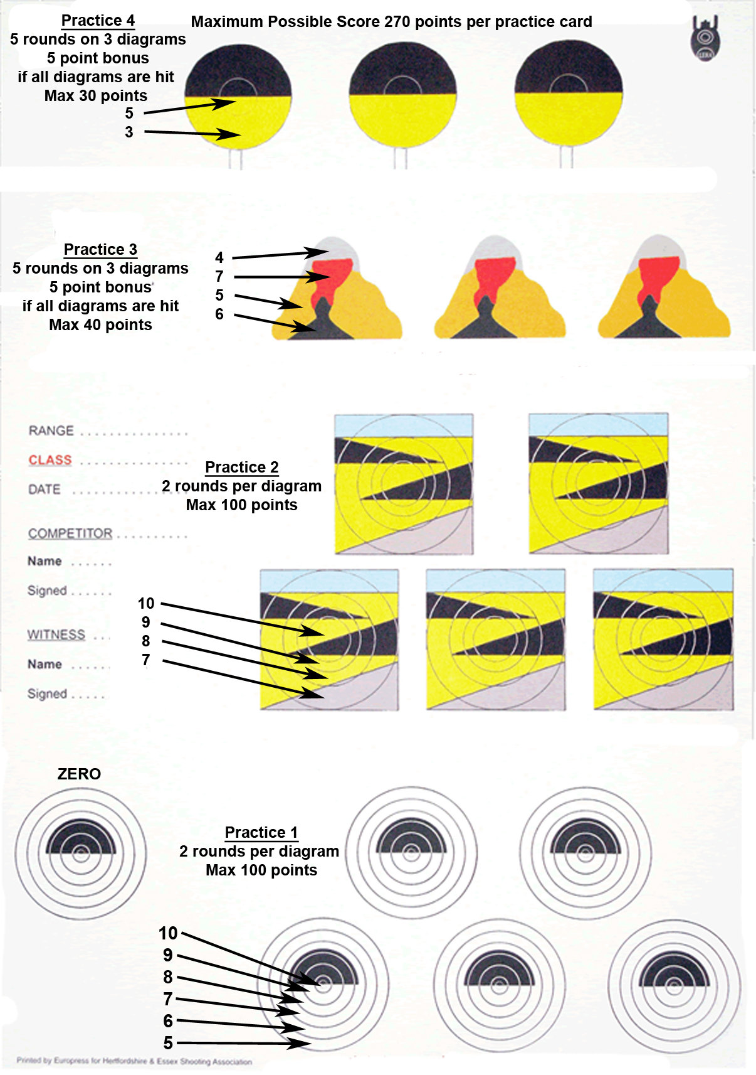
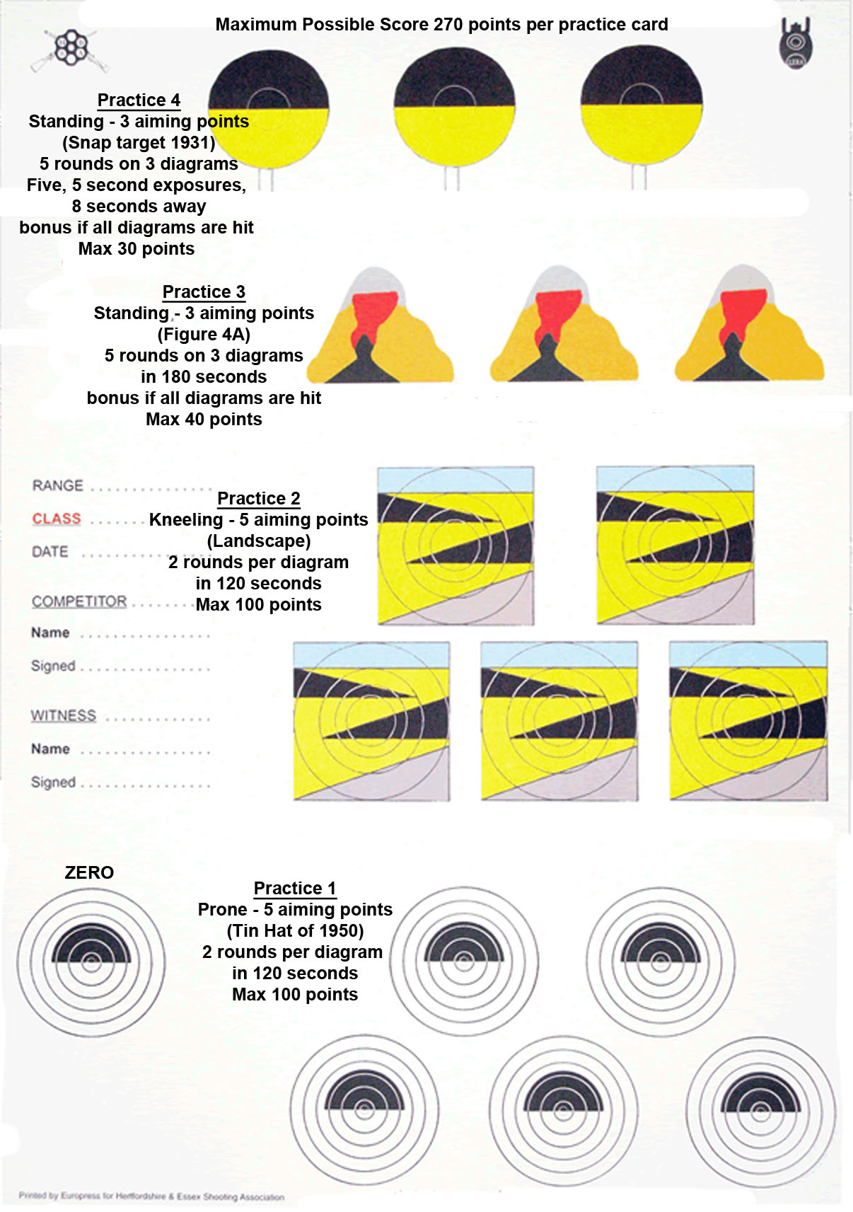
ENTRY FORM
Field Firing Match 4th April 2020 – (Note: this is a 3 position, rapid fire match, not slow fire)

Name
_______________________________________________________________________________________________________________________________________

Address
_______________________________________________________________________________________________________________________________________

Tel No. (Day) (Eve) E-Mail
_______________________________________________________________________________________________________________________________________

I wish to enter the HESA Small-bore Open Meeting conducted in accordance with HBSA Rules for the Conduct of Shooting and Competition 1995 and the Match Conditions as shown with this entry form.

I am: a Member of HESA*/HBSA*/LERA*/OTHER* (please state below) Signature ___________________________________

___________________________________________________________________________________________________________
_
Preferred shooting time AM */ PM* (*delete if not applicable)

Please state if you wish to be squaded with other shooters _____________________________________________________________

Entry Fees regardless of Match/Class – First entry £6.00; Second entry; £5.00; Third entry £4.00

Match | Class | Rifle make/model | Entry Fee | Total
Match I | Vintage (pre-1888) Any Rifles  (any contemporaneous iron sights). |  | £6/£5/£4
Match II | Classic Service (1889-1918) ∙22” & Service Training Rifles (issue sights). |  | £6/£5/£4
Match III | Classic (1889-1918) ∙22” & Service (any contemporaneous iron sights). |  | £6/£5/£4
Match IV | Veteran Service (1919-1945) Service Training Rifles (issue sights). |  | £6/£5/£4
Match V | Veteran (1919-1945) Any Rifles  (any contemporaneous iron sights). |  | £6/£5/£4
Match VI | Post Veteran (1946-1960) Any Rifles (any contemporaneous iron sights). |  | £6/£5/£4
Match VII | Modern Rifles (post 1960) with contemporaneous iron sights. |  | £6/£5/£4
Match VIII | Sniper Rifles (any date line) single shot with telescopic sights. |  | £6/£5/£4
Match IX | Semi Auto Rifles (Self loading) (Telescopic Sights). |  | £6/£5/£4
Match X | Semi Auto Rifles (Self loading) (Open/Iron Sights). |  | £6/£5/£4
Match XI | Air Rifles (Pre-charged). |  | £6/£5/£4
Cheques are payable to Herts & Essex shooting Association (HESA) Total Entry Fee
HESA reserve the right to accept or refuse entries without recourse
3% Handicap will apply for magazine use, (except Matches IX & X)
If you are unable to shoot in all three positions, you may still enter, please advise us in advance, 5% Handicap may apply.

Entries to: Herts & Essex Shooting Association
“Amapola” Magdalene Crescent E-mail: Kim@455.org.uk or
Silver End FFM@hesa.uk.com
Witham
Essex
CM8 3XP

